**VISVESWARAYA TECHNOLOGICAL UNIVERSITY Jnana Sangama, Belagavi-590018**

**BMS INSTITUTE OF TECHNOLOGY &MANAGEMENT**

***YELAHANKA, BENGALURU-560064***

DEPARTMENT OF COMPUTER SCIENCE & ENGINEERING

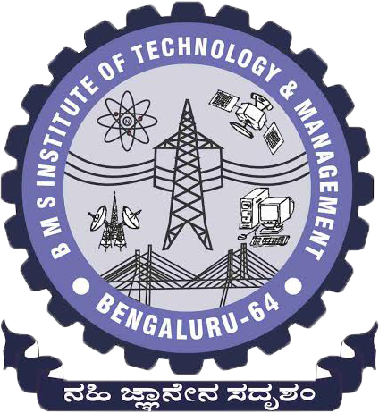

***CERTIFICATE***

This is to certify that the internship work entitled “**ERP - Data Migration**” is a bonafide work carried out by **Likith S(1BY18CS081)** in partial fulfillment for the requirement of ***Bachelor of Engineering degree in Computer Science and Engineering of Visvesvaraya Technological University, Belagavi*** during the academic year 2021-22. It is certified that all corrections/suggestions indicated for the internal assessment have been incorporated in the report deposited in the departmental library.

**External Guide Signature of the Guide Signature of the HOD**

**Mr. Korhan Dulge Mrs. Durga Bhavani A Dr. Thippeswamy G**

**Senior IT Delivery Lead Assistant Professor Professor& Head**

**Johnson Controls Department of CSE Department of CSE**

**BMSIT & M BMSIT & M**

Name of the Examiners Signature with Date

## 1.



2. 

**DECLARATION**

I hereby declare that the Internship report entitled “**ERP - Data Migration**” submitted to the BMS Institute of Technology & Management, Yelahanka, Bengaluru has been carried out by me and submitted in partial fulfillment of the course requirements for the award of a degree in Bachelor of Engineering in Computer Science and Engineering of Visvesvaraya Technological University, Belagavi, during the academic year 2021 - 2022. The matter embodied in this report has not been submitted to any other university or institution for the award of any other degree.

***Signature of the Student***

### Likith S

### USN: 1BY18CS081